**MODULE 5**

**ASSIGNMENT 1**

**Advance topics in a function**

**1) Write a function add to add two numbers and call the function in another file.**

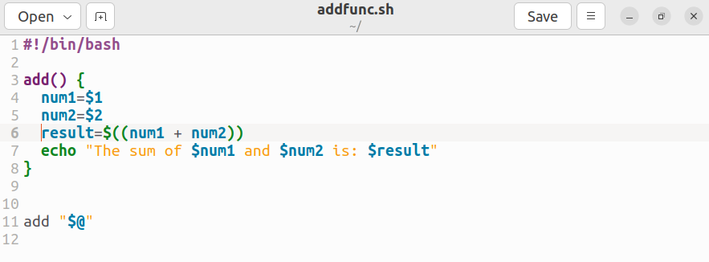

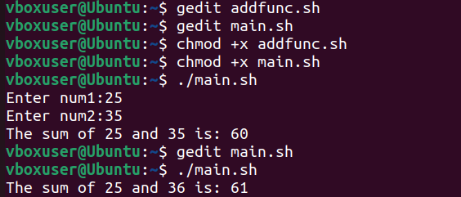

**ASSIGNMENT 2**

**Recursive function**

**1) Write a program where the recursive function calculates the sum of N numbers**

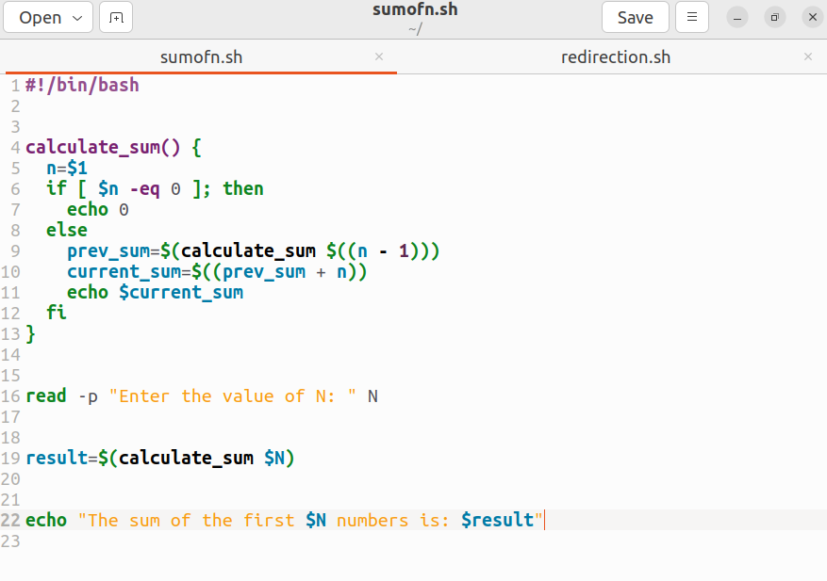

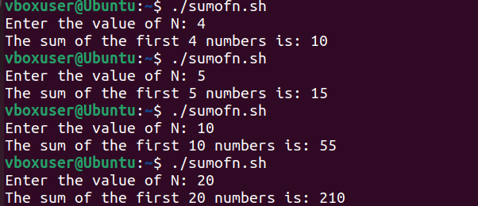

**ASSIGNMENT 3**

**Basics of Redirection (error handling)**

**1) Write a program in any language like C, C++, Java.**

**2) And redirect the output or error to a new file.**

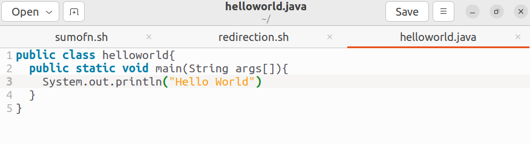

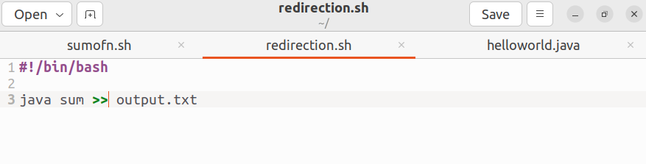

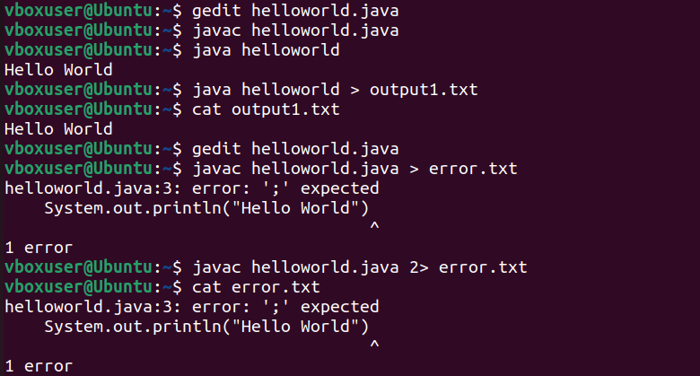

**ASSIGNMENT 4**

**More on Redirection**

**1) Create X_file.txt file with some content.**

**2) Redirect the content of both out_file.txt and X_file.txt to a new file**

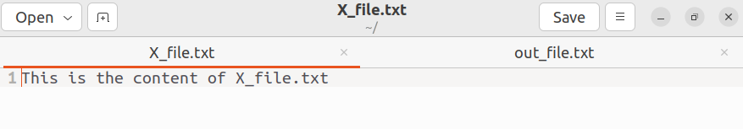

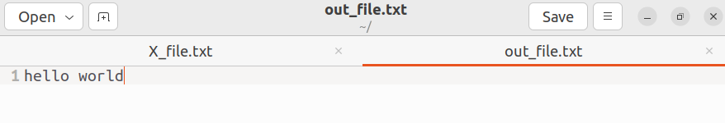

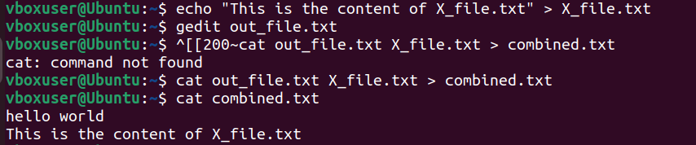

**ASSIGNMENT 5**

**Here document and Here string**

**1) Convert a string to uppercase using:**

**a) Here document**

**b) Here string**

**Hint: tr a-z A-Z**

